Name-Ujjawal Mandhani
Batch-F6
Enroll No.-9918103237
OSSP Lab-9

Question 1:

First Fit:

#include <stdio.h>

void main()
{
int bsize[10], psize[10], bno, pno, flags[10], allocation[10], i, j;

for (i = 0; i < 10; i++)
{
flags[i] = 0;
allocation[i] = -1;
}
printf("Enter no. of blocks: ");
scanf("%d", &bno);
printf("\nEnter size of each block: ");
for (i = 0; i < bno; i++)
scanf("%d", &bsize[i]);

printf("\nEnter no. of processes: ");
scanf("%d", &pno);
printf("\nEnter size of each process: ");
for (i = 0; i < pno; i++)
scanf("%d", &psize[i]);
for (i = 0; i < pno; i++) //allocation as per first fit
for (j = 0; j < bno; j++)
if (flags[j] == 0 && bsize[j] >= psize[i])
{
allocation[j] = i;
flags[j] = 1;
break;
}
//display allocation details
printf("\nBlock no.\tsize\t\tprocess no.\t\tsize");
for (i = 0; i < bno; i++)
{
printf("\n%d\t\t%d\t\t", i + 1, bsize[i]);
if (flags[i] == 1)
printf("%d\t\t\t%d", allocation[i] + 1, psize[allocation[i]]);
else
printf("Not allocated");
}
}

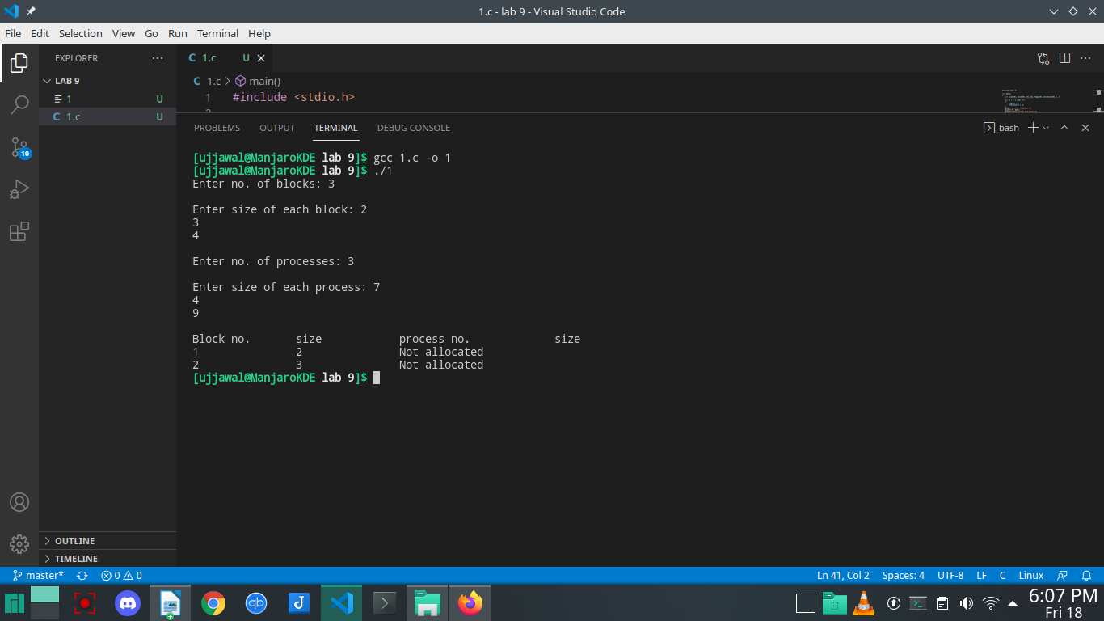
Worst Fit:

#include <stdio.h>

int main()
{
int fragments[10], blocks[10], files[10];
int m, n, number_of_blocks, number_of_files, temp, top = 0;
static int block_arr[10], file_arr[10];
printf("\nEnter the Total Number of Blocks:\t");
scanf("%d", &number_of_blocks);
printf("Enter the Total Number of Files:\t");
scanf("%d", &number_of_files);
printf("\nEnter the Size of the Blocks:\n");
for (m = 0; m < number_of_blocks; m++)
{
printf("Block No.[%d]:\t", m + 1);
scanf("%d", &blocks[m]);
}
printf("Enter the Size of the Files:\n");
for (m = 0; m < number_of_files; m++)
{
printf("File No.[%d]:\t", m + 1);
scanf("%d", &files[m]);
}
for (m = 0; m < number_of_files; m++)
{
for (n = 0; n < number_of_blocks; n++)
{
if (block_arr[n] != 1)
{
temp = blocks[n] - files[m];
if (temp >= 0)
{
if (top < temp)
{
file_arr[m] = n;
top = temp;
}
}
}
fragments[m] = top;
block_arr[file_arr[m]] = 1;
top = 0;
}
}
printf("\nFile Number\tFile Size\tBlock Number\tBlock Size\tFragment");
for (m = 0; m < number_of_files; m++)
{
printf("\n%d\t\t%d\t\t%d\t\t%d\t\t%d", m, files[m], file_arr[m], blocks[file_arr[m]], fragments[m]);
}
printf("\n");
return 0;
}

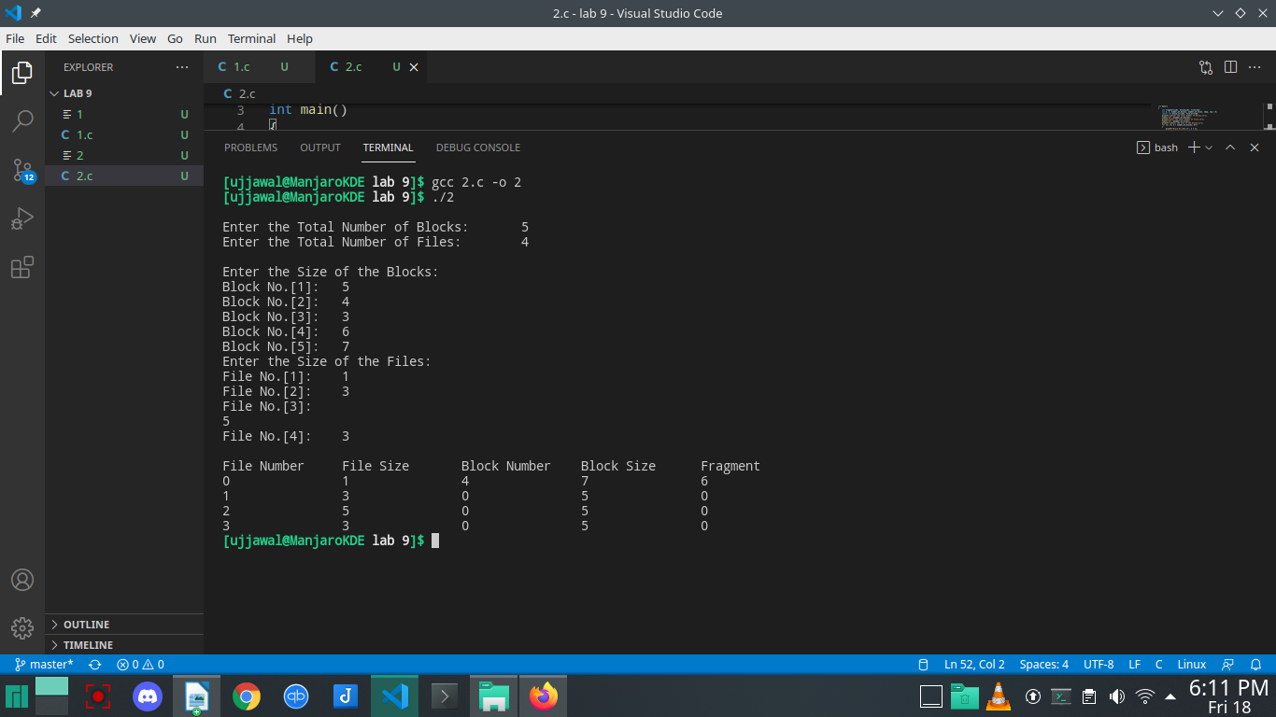
Best Fit:
#include <stdio.h>

int main()
{
int fragments[10], block[10], file[10], m, n, number_of_blocks, number_of_files, temp, lowest = 10000;
static int block_arr[10], file_arr[10];
printf("\nEnter the Total Number of Blocks:\t");
scanf("%d", &number_of_blocks);
printf("\nEnter the Total Number of Files:\t");
scanf("%d", &number_of_files);
printf("\nEnter the Size of the Blocks:\n");
for (m = 0; m < number_of_blocks; m++)
{
printf("Block No.[%d]:\t", m + 1);
scanf("%d", &block[m]);
}
printf("Enter the Size of the Files:\n");
for (m = 0; m < number_of_files; m++)
{
printf("File No.[%d]:\t", m + 1);
scanf("%d", &file[m]);
}
for (m = 0; m < number_of_files; m++)
{
for (n = 0; n < number_of_blocks; n++)
{
if (block_arr[n] != 1)
{
temp = block[n] - file[m];
if (temp >= 0)
{
if (lowest > temp)
{
file_arr[m] = n;
lowest = temp;
}
}
}
fragments[m] = lowest;
block_arr[file_arr[m]] = 1;
lowest = 10000;
}
}
printf("\nFile Number\tFile Size\tBlock Number\tBlock Size\tFragment");
for (m = 0; m < number_of_files && file_arr[m] != 0; m++)
{
printf("\n%d\t\t%d\t\t%d\t\t%d\t\t%d", m, file[m], file_arr[m], block[file_arr[m]], fragments[m]);
}
printf("\n");
return 0;
}

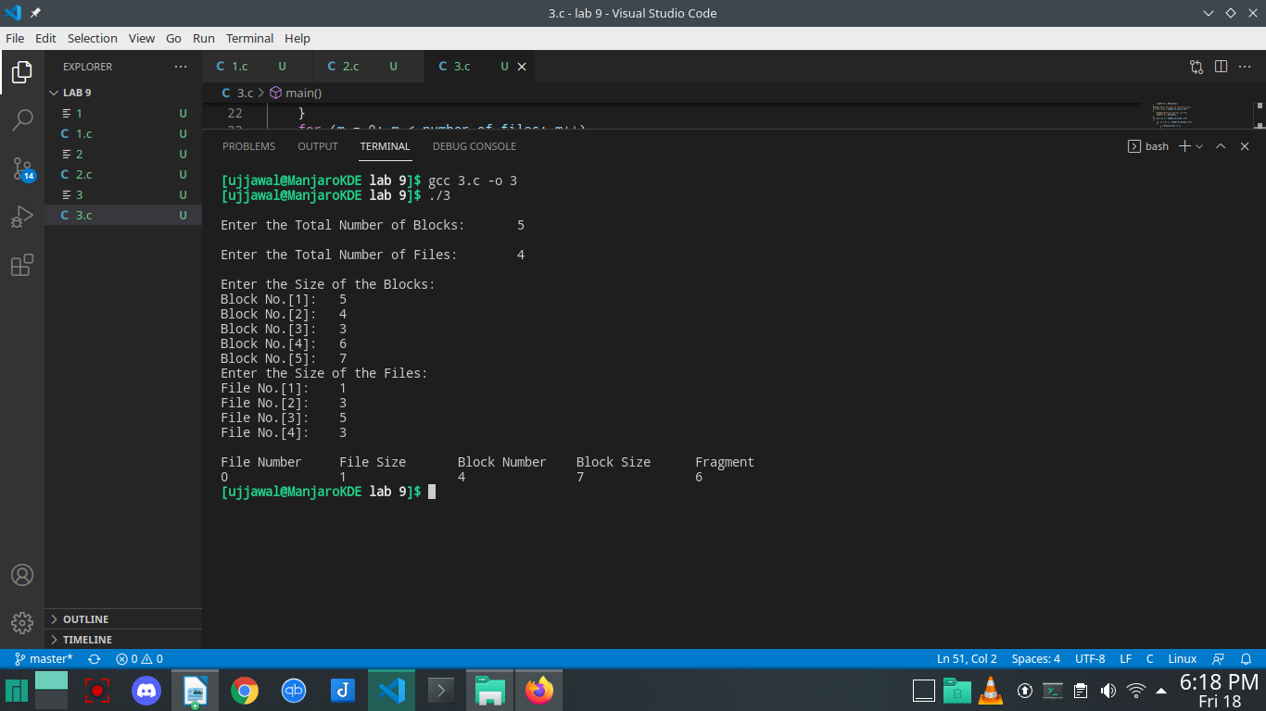
Question 2:

#include <stdio.h>
#include <string.h>
#include <stdlib.h>

struct
{
char dname[10], fname[10][10];
int fcnt;
} dir;

void main()
{
int i, ch;
char f[30];
// clrscr();
dir.fcnt = 0;
printf("\nEnter name of directory -- ");
scanf("%s", dir.dname);

while (1)
{
printf("\n\n1. Create File\t2. Delete File\t3. Search File \n4. Display Files\t5. Exit\nEnter your choice -- ");

scanf("%d", &ch);

switch (ch)
{
case 1:
printf("\nEnter the name of the file -- ");
scanf("%s", dir.fname[dir.fcnt]);
dir.fcnt++;
break;

case 2:
printf("\nEnter the name of the file -- ");
scanf("%s", f);
for (i = 0; i < dir.fcnt; i++)
{
if (strcmp(f, dir.fname[i]) == 0)
{
printf("File %s is deleted ", f);
strcpy(dir.fname[i], dir.fname[dir.fcnt - 1]);
break;
}
}

if (i == dir.fcnt)
printf("File %s not found", f);
else
dir.fcnt--;
break;

case 3:
printf("\nEnter the name of the file -- ");
scanf("%s", f);
for (i = 0; i < dir.fcnt; i++)
{
if (strcmp(f, dir.fname[i]) == 0)
{
printf("File %s is found ", f);
break;
}
}
if (i == dir.fcnt)
printf("File %s not found", f);
break;

case 4:
if (dir.fcnt == 0)
printf("\nDirectory Empty");
else
{
printf("\nThe Files are -- ");
for (i = 0; i < dir.fcnt; i++)
printf("\t%s", dir.fname[i]);
}
break;

default:
exit(0);
}
}
//getch();
}

